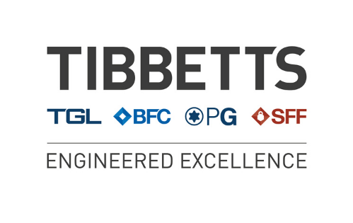

The Tibbetts Group
Ethical Working Practice
(All Sites)

The Tibbetts Group- Ethical Policy
This policy identifies our expectations concerning business conduct that are essential for companies that do business with The Tibbetts Group. We also believe that these Standards will serve to advance the performance of our companies to our mutual benefit. Therefore, compliance with The Tibbetts Group Ethical Working Practice is a mandatory component of all The Tibbetts Group purchase and supply contracts.
We appreciate your thorough review of the standards set forth in this Guide and to Sign your acceptance at the end of this document.
Respect for People:
We expect every The Tibbetts Group supplier to abide by all applicable employment laws. We will not allow the use of any forced or involuntary labour by suppliers who provide goods or services to The Tibbetts Group
The Tibbetts Group also expects its suppliers to provide employee wage and benefit levels that satisfy basic needs in light of local conditions.
Promote a Safe and Positive Workplace:
The Tibbetts Group expects its suppliers to provide its employees with a safe and healthy work environment and to abide by all applicable health and safety laws.
Protect our Environment:
We expect that our suppliers will abide by all local environmental laws and regulations. We also encourage our suppliers to seek external verification concerning their environmental performance, such as through the ISO 14001 certification process.
(The Tibbetts Group companies are ISO 14001 certified and the environmental policy is available and copy certificates via the website www.tibbettsgroup.co.uk)
Product Safety:
The Tibbetts Group suppliers are expected to take all reasonable safety measures in connection with the design and manufacture of products it sells to The Tibbetts Group. It is the obligation of every Tibbetts Group supplier to inform The Tibbetts Group immediately if a question concerning safety of a product sold to The Tibbetts Group arises.

Gifts, Favours and Entertainment:
The Tibbetts Group will select its suppliers on the basis of total value, including quality, price and services offered. Therefore, suppliers should not give gifts, favours or entertainment to The Tibbetts Group employees that is of any monetary value or that is inappropriate or unbecoming. While the personal relationships that we form during the course of our business activities are a rewarding aspect of our association, The Tibbetts Group employees are not allowed to use these relationships as a basis for making a purchasing source selection. You must respect this expectation and not try to unfairly influence a purchasing source selection through inappropriate gratuities. And, if a The Tibbetts Group employee solicits you for a gift or a favour, you should report that matter to a Director of The Tibbetts Group.
(The Tibbetts Group companies HR policy HR04 – Anti Bribery and Corruption policy is available to all employees)
Negotiating, Fairly and Honestly:
Information which you give to The Tibbetts Group during the course of negotiations must be accurate. You must not attempt to improperly influence the course of negotiations through any deceptive means. You must abide by all laws and regulations that may affect our business together, including laws related to fair competition and trade practices.
Good Ethics is Good Business:
In our partnership in business together, we believe that adherence to the above principles will serve both of our companies well. If you have any questions concerning whether particular conduct related to your supply of goods or services to The Tibbetts Group is appropriate, we invite you bring that matter to the attention of your business contact at The Tibbetts Group. He or she will provide assistance or will seek additional guidance as appropriate.
If you are happy with our supplier expectations please sign below:
Name
On behalf of
Date

