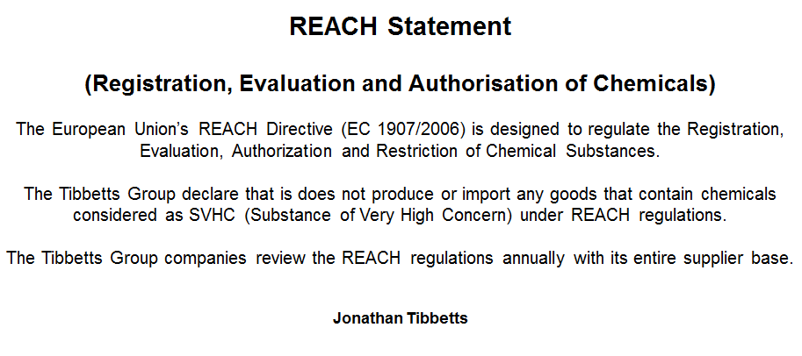

Jonathan Tibbetts
Managing Director
The Tibbetts Group Ltd

